SCAPE PUBLIC ART MEETS SCIENCE IN NEIL PARDINGTON EXHIBITION

Neil Pardington’s confronting images of creatures in jars will spill out of Canterbury Museum into Hagley Park in a collaborative exhibition as part of SCAPE’s Public Art Season 2019.
The Order of Things will unveil new images of animals, birds, invertebrates and fish that are preserved in jars as part of Canterbury Museum’s collection – bringing these rarely seen scientific specimens out of the storeroom and putting them on public display. An extension of an existing project, The Order of Things will also likely include images from other museum collections.
The images will be on display at the Museum and on billboards throughout Hagley Park during SCAPE’s Season, a citywide festival that runs from 5 October to 16 November. The images taken at Canterbury Museum link to our sense of location and home – a key theme of the Season that takes the game Rock : Paper : Scissors as its starting point.
“I had actually finished The Order of Things when SCAPE contacted me about being a part of their Season,” Neil says.
“Once this was suggested, I thought it would be good to shoot new images that relate to where they’ll be shown. All of the new photographs are of creatures from Canterbury Museum’s collection – many from the local area – and so have a strong connection to place.”
The Museum specimens being photographed float in glass jars of alcohol solution, meaning the images need to strike a careful balance between beauty and the grotesque, Neil says.
“Some are beautiful but some of these images are quite tough and brutal. That’s a reflection of the world we live in.”
SCAPE Managing Curator Emma Bugden says the way things are arranged, including Museum collections, conveys a lot about what we value.
“Meticulously named and ordered, what do these ghostly creatures tell us about our world?” she asks.
“Museums, like science, use a natural history classification system first developed by Swedish botanist Carl Linnaeus in the 1700s. In Aotearoa, this system replaced mātauranga Māori – a genealogically-based way of understanding which tracked important relationships and provided morality tales. Such stories, for instance, described the tuatara as a close relative of the shark.
“The erasure of these connections is one thread in the dismantling of Māori histories and beliefs through colonisation. Titled after the seminal book by Michel Foucault, The Order of Things shows us that the act of naming and classifying is not a given, but instead, a set of conventions that shape our understanding.”
This is the third year in a row that SCAPE has included billboards in Hagley Park as part of its Season.
“It’s a great way of extending the reach of the SCAPE Seasons to new audiences and the billboards provide an ideal platform for photographers,” says SCAPE Executive Director Deborah McCormick.
“The Order of Things also reflects the fascination artists have with science and the natural world – many are intrigued with museum collections.”
SCAPE’s Season 2019 is New Zealand’s pre-eminent public art festival, featuring more than a dozen artworks that make us think and feel: about what home means, the emotional resonance of materials, and the patterns and rituals that help us make sense of the world.
ENDS
Please refer to high resolution image folder here

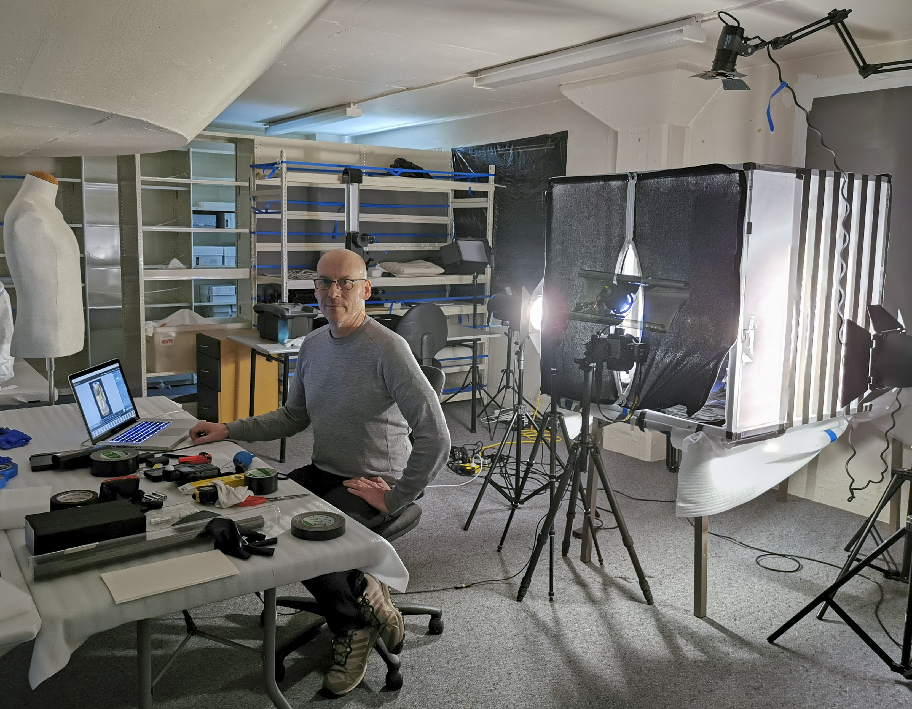
Caption: Artist Neil Pardington shoots new images for The Order of Things at Canterbury Museum using a purpose-built photography booth that controls reflections on the glass jars.

About the collaboration with Canterbury Museum
The Order of Things is the third collaboration between SCAPE and Canterbury Museum as part of SCAPE’s annual Seasons.
Museum Director Anthony Wright says the Museum is always keen to open up its research collections to the public.
“Projects like this are a fantastic way to show our collections in a new light. We really value the opportunity to work with an artist of Neil’s calibre to provide alternative access to some of the wonders from behind the scenes.
“SCAPE has a terrific track record in delivering exciting contemporary public art which engages broad audiences, and this collaboration is a great platform for us to show off the Museum collection – both inside and outside the building.”

About the artist
Neil Pardington (Kāi Tahu, Kāti Mamoe, Ngāti Kahungunu, Pākehā) is a photographer and designer based in Wellington.
He has exhibited widely, including the major Christchurch Art Gallery exhibition The Vault: Neil Pardington (2009) which toured to City Gallery (2011) and Otago Museum (2010).
Recent solo exhibitions include Solo 2016: Six Wellington Artists at The Dowse Art Museum. His work is currently touring in the major exhibition Civilisation: The Way We Live Now, National Museum of Modern and Contemporary Art, Seoul (2018); Ullens Center for Contemporary Art, Beijing (2019); National Gallery of Victoria, Melbourne (2019) and Auckland Art Gallery (2020).
Other group exhibitions include Mortality, Australian Centre for Contemporary Art, Melbourne (2010), Toi Te Papa: Art of a Nation, Museum of New Zealand Te Papa Tongarewa (2006), Public/Private Tumatanui/Tumataiti: the 2nd Auckland Triennial, Auckland Art Gallery (2004) and Prospect 2004: New Art New Zealand, City Gallery Wellington.
In 2011 he received the Arts Foundation Marti Friedlander Photographic Award and in 2016 Baker Douglas published The Order of Things, a monograph on his work. He is represented by Jonathan Smart Gallery, Christchurch and {Suite} Wellington.

About the SCAPE Public Art Trust
SCAPE Public Art installs public art in Christchurch all year round, with a focus on the annual public art festival Seasons. SCAPE is the Christchurch expert in the installation of public art, and the SCAPE Public Art Seasons are New Zealand's premier public art events.
Held in Christchurch’s central city public spaces and supported through a range of partnerships, the Seasons showcase leading national and international contemporary artists, and provide a springboard for emerging local talent. Artworks in the Seasons are created as a result of close collaboration between art and business. This is a highly regarded model world-wide.
Our Seasons provide an opportunity to focus on the introduction of new artworks while maintaining focus on the impressive base of legacy pieces. www.scapepublicart.org.nz
For media comment please contact:
Deborah McCormick
Executive Director
SCAPE Public Art
Tel: +64 (0)3 365 7990
Mobile: +64 (0)27 280 9557
Email: deborah@scapepublicart.org.nz

Carolyne Grant
Philanthropy & Communications Manager
SCAPE Public Art
Tel: +64 (0)3 365 7990
Mobile: +64 (0)21 660 715
Email: carolyne@scapepublicart.org.nz

