**SCAPE Artworks Bring Splash of Spring Colour to Central City**

Two new brightly coloured, abstract artworks by Aotearoa artists will radiate from separate central city locations this spring as part of SCAPE Public Art’s Season 2019.

Natalie Guy’s *The Pool* (2018–19) and Tyler Jackson’s *Modulating Monolith* (2019) are located within easy walking distance from each other for the six-week Season that opens on 5 October.   
  
Poised ready for the plunge, Guy’s diving board overlooks the Ōtākaro Avon River at the corner of Cambridge Terrace and Hereford streets, while Jackson’s glowing rectangular cube is located next to Christchurch Casino.  
  
The diving board is pointedly not positioned above a swimming pool. Stripped of its core business as a launching pad, Guy says it “becomes a surreal, redundant and inaccessible object.”  
  
*The Pool* references both David Hockney’s iconic and luxurious Californian paintings, and British architect Jane Drew. Drew was a major contributor to the design of the Indian city of Chandigarh, planned in the 1950s as a modernist utopia.

A leader in her field at a time when female architects were rare, Drew produced many of Chandigarh’s features, including a pool and diving board for a private swimming club.   
  
“Pools would have been a rarity in 1950s Chandigarh. Much like the city itself, which is an isolated island of modernist architecture and ordered urban design, it harbours a sense of other-worldliness,” Guy says.  
  
Down the road, the utilitarian shape of Jackson’s *Modulating Monolith* suggests a shed or public amenity, however it pulsates with light and colour.  
  
“It draws us close but allows no access through its radiant but impenetrable skin,” SCAPE Managing Curator Emma Bugden says.  
  
“The fleeting nature of light is contrasted with the robust, industrial nature of Jackson’s materials. At a time when our relationship to plastics is increasingly conflicted, *Monolith Modulator* is both seductive and elusive.”  
  
The artwork continues Jackson’s interest in the history of artists working in light and this work emits luminosity in a diffuse way.   
  
“I’m interested in the immateriality of light. Obviously, colour is the offspring of light – so the immateriality of colour as well,” Jackson says.  
  
Season 2019 features more than a dozen artworks linked by the SCAPE Public Art Walkway, with people encouraged to get the Season map and either self-guide or join a guided tour.

Aotearoa New Zealand’s pre-eminent public art festival, SCAPE Season 2019 takes the iconic game *Rock : Paper : Scissors* as its starting point, featuring artworks that make us think and feel: about what home means, the emotional resonance of materials, and the patterns and rituals that help us make sense of the world.

It runs from 5 October to 16 November, with the Season map available at central city locations from the end of September.

ENDS

[Please refer to high resolution image folder here](https://www.dropbox.com/sh/dueweh7ykun4hh8/AAD1gD6FEPrL4oYHg1WRg-U1a?dl=0).

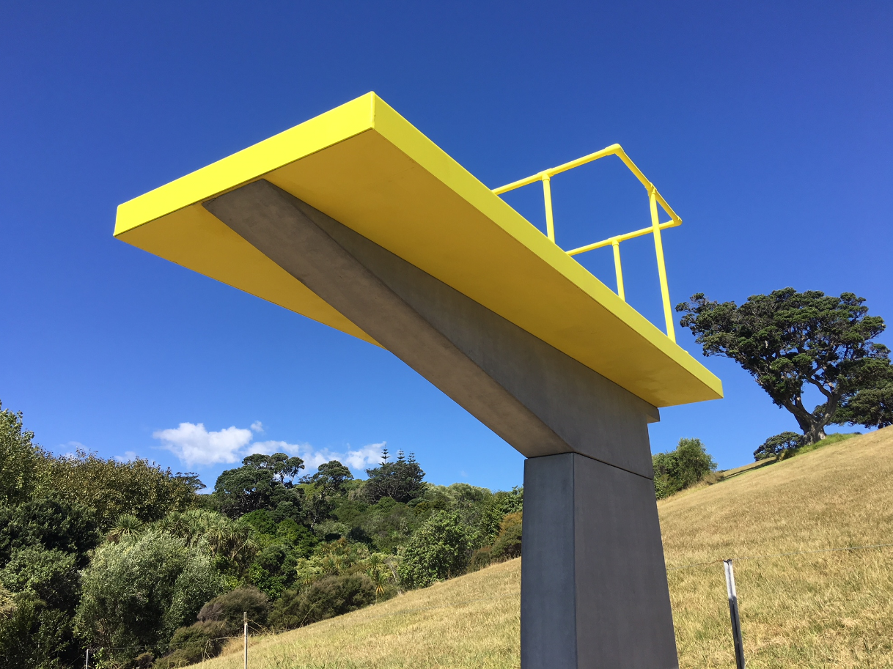

Natalie Guy *The Pool* 2018–19. Image courtesy of the artist and SCAPE Public Art

Tyler Jackson *Modulating Monolith* 2019. Image courtesy of the artist and SCAPE Public Art

**About the artists**

**Natalie Guy** is a sculptor based in Auckland. Her work has been included in a number of public sculpture festivals, such as *Sculpture on the Gulf,* Waiheke Island (2019); *Sculpture in the Gardens*, Auckland Botanic Gardens (2017) and *Sculpture on Shore,* Fort Takapuna (2016).   
  
She has undertaken artist residencies at Sculpture Space, Utica New York (2019); Bundanon Trust, NSW Australia (2018) and an Asia NZ residency at Kiriti Gallery, Varanasi, India (2017).  
  
Solo exhibitions include *Modern with a Petit M*, Hastings City Art Gallery (2018) and *Then and Then Again*, Malcolm Smith Gallery, Auckland (2018).   
  
She is represented by Fox Jensen Gallery, Sydney and Fox Jensen McCory Gallery, Auckland.   
  
  
**Tyler Jackson** is a Wellington/Te Whanganui-a-Tara-based emerging artist and facilitator at the artist-run space play_station.   
  
He graduated with a Bachelor of Fine Arts with first class honours from Massey University in 2016. During his study, Jackson was the recipient of the NZ Art Show’s R T Nelson NZ Emerging Artist award.   
  
Recent projects include: *Speed Dating 3.0,* play_station, Wellington (2019); *Nikau Hindin, Salome Tanuvasa, Sam Kelly, Tyler Jackson*, Millers O’Brien, Wellington (2019); *Courtship*(with Robbie Handcock), Auckland Art Fair (2019); *Between the beach and the lounge*, Biquini Wax EPS, Mexico City (2018) and *Traces: the part encodes the whole*, [tacit] gallery, Hamilton (2018).  
  
*Monolith Modulator* is the second iteration of an artwork debuted at *Sculpture on the Gulf*, Waiheke Island (2019).

**About the SCAPE Public Art Trust**

SCAPE Public Art installs public art in Christchurch all year round, with a focus on the annual public art festival Seasons. SCAPE is the Christchurch expert in the installation of public art, and the SCAPE Public Art Seasons are New Zealand's premier public art events.  
  
Held in Christchurch’s central city public spaces and supported through a range of partnerships, the Seasons showcase leading national and international contemporary artists, and provide a springboard for emerging local talent. Artworks in the Seasons are created as a result of close collaboration between art and business. This is a highly regarded model world-wide.

Our Seasons provide an opportunity to focus on the introduction of new artworks while maintaining focus on the impressive base of legacy pieces. [www.scapepublicart.org.nz](http://www.scapepublicart.org.nz)  
  
**For media comment please contact:**

**Deborah McCormick**

Executive Director

SCAPE Public Art  
Tel: +64 (0)3 365 7990  
Mobile: +64 (0)27 280 9557  
Email: [deborah@scapepublicart.org.nz](mailto:deborah@scapepublicart.org.nz)

**Carolyne Grant**

Philanthropy & Communications Manager

SCAPE Public Art

Tel: +64 (0)3 365 7990

Mobile: +64 (0)21 660 715

Email: [carolyne@scapepublicart.org.nz](mailto:carolyne@scapepublicart.org.nz)